
User Guide
(CogniOpen - Nurturing Memory Wellness for Cognitive Impairment)

Submitted to:

University of Maryland Global Campus in partial fulfillment of the course Software Engineering Capstone (SWEN 670)

Submitted By: Team B

Fall Semester 2023

Version 1.0

November 4, 2023
Department of Software Engineering
University of Maryland Global Campus (UMGC)

Table of Contents
1 Introduction 6
1.1 Purpose 6
1.2 Project Documents 6
1.3 Acronyms, Definitions, and Abbreviations 6
1.4 Overview 7
1.5 Scope 8
2 Setup 8
2.1 Device Requirements 8
2.2 Installation 8
3. Initial Use 14
3.1 Application Permissions 14
4. Application Usage 17
4.1 Registration 17
4.2 Onboarding 19
4.3 Login 22
4.4 Home 24
4.5 Guided Tour 24
4.6 Profile 27
4.7 Record Audio 29
4.8 Audio Gallery 32
4.9 Virtual Assistant 34

Table of Tables

Table 1: Project Documents 5
Table 2: Definitions, Acronyms, and Abbreviations 6

Table of Figures
Figure 1: App Settings 8
Figure 2: Special Access 8
Figure 3: Install Unknown Apps 9
Figure 4: Allow Chrome to Download 9
Figure 5: Download the Application 10
Figure 6: Allow Download Exception 10
Figure 7: Download Anyway 11
Figure 8: Open Application Download 11
Figure 9: Install Application 12
Figure 10: Finish Installation 12
Figure 11: View Installed Application 13
Figure 12: Location Permissions 14
Figure 13: Camera Permissions 14
Figure 14: Microphone Permissions 15
Figure 15: File Permissions 15
Figure 16: Register for Account 16
Figure 17: Registration Form 17
Figure 18: Create Account 17
Figure 19: Introduction to the Application 18
Figure 20: Cora Introduction 19
Figure 21: Cora Memories 19
Figure 22: Cora Conversation Summary 20
Figure 23: Cora Recording Done 20
Figure 24: Onboarding Complete 21
Figure 25: Login Prompt 22
Figure 26: Biometric Authentication 22
Figure 27: Home Screen 23
Figure 28: Home Screen Tour Guide Option 24
Figure 29: Swipe Through Guided Tour 25
Figure 30: Return to Home Screen 25
Figure 31: Click Profile Menu Option 26
Figure 32: Profile Form 27
Figure 33: Finish Profile Form 28
Figure 34: Home Screen Record Audio Option 29
Figure 35: Stop Audio Recording 29
Figure 36: Transcribing Recording 30
Figure 37: Post Recording Transcription 31
Figure 38: Home Screen Gallery Option 32
Figure 39: Select an Audio Recording 32
Figure 40: View Audio Recording 33
Figure 41: Home Screen Virtual Assistant Option 34
Figure 42: Cora Prompt 35
Figure 43: Cora Response 35

1 Introduction

1.1 Purpose
This user guide (UG) is designed to ensure that an end user of the CogniOpen application is equipped to download, install, and run the application. The UG is written in a way to remove any ambiguity, in order to alleviate technical difficulties. By the end of the document, a user should have the application installed and working.

1.2 Project Documents
This document is one part of the deliverables for the CogniOpen project. The other documents are listed in the table below with the most recent version of each at the time of editing this Programmer Guide.
Document | Version | Date
Project Plan (PPL) | 1.2 | 10/28/2023
Software Requirements Specification (SRS) | 1.2 | 10/28/2023
Technical Design Document (TDD) | 1.1 | 10/28/2023
Test Plan (TP) | 1.1 | 10/28/2023
Programmer Guide (PG) | 1.0 | 10/28/2023
Deployment and Operations Guide (DOG) | 1.0 | 10/28/2023
Software Test Report (STR) | - | -
User Guide (UG) | - | -
Traceability Matrix (TM) | - | -
Table 1: Project Documents

1.3 Acronyms, Definitions, and Abbreviations

Term | Definition
ADO | Azure DevOps
API | Application Programming Interface
App | A program that is included on the User’s mobile device
AWS | Amazon Web Services
Cora | CogniOpen Remote Assistant
HTTPS | Hypertext Transfer Protocol Secure
IAM | Identity and Access Management
IDE | Integrated development environment
iOS | iPhone Operating System
MB | Megabytes
Mobile Device | A smart phone, tablet, or some other portable computer with either the iOS or Android operating system
MVC | Model View Controller
OS | Operating System
REST | Representational State Transfer
SDK | Software Development Kit
SNS | Simple Notification Service
TDD | Technical Design Document
UI | User Interface
UMGC | University of Maryland Global Campus
UX | User Experience
Table 2: Definitions, Acronyms, and Abbreviations

1.4 Overview
The UG is broken up into four sections: the introduction, application setup, initial use, and prolonged application usage. The introduction provides a high-level summary of what the UG is developed to do. The application setup section will guide end users through the download and setup of the application. The initial use section will guide new users through their first interactions with the CogniOpen application. Finally, the prolonged application usage section will enumerate the possible features that the end user has access to.

1.5 Scope
The UG will only cover features developed by Team B. All other features within the application will be provided by the group Team B is collaborating with. The Team B features include the user registration, user login, the home page, a guided tour of the application, updating a user’s profile, recording audio, viewing audio recordings in the gallery, and interacting with the virtual assistant.

2 Setup

2.1 Device Requirements
To run the CogniOpen application, an Android or iOS device with a supported operating system must be available. Android version 11 and above are all supported for installation and deployment of the CogniOpen application. iOS version 12 or 15 and above are all supported for installation and deployment. These phones must have access to the internet, a working microphone, and/or a working camera. Finally, the application requires a minimum of 121 megabytes (MB) to install. For local storage, 250 MB of storage is recommended to ensure optimal application performance and storage requirements.

2.2 Installation
To install the CogniOpen application, user’s will have to give their phones permissions to install unverified applications. In the future, the CogniOpen application will be available in the Google Play store the Apple App Store. Execute the following steps to allow your phone to install unverified applications:
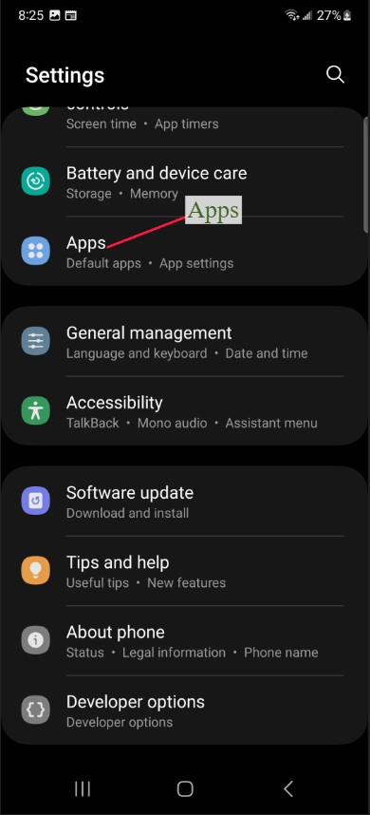
Figure 1: App Settings
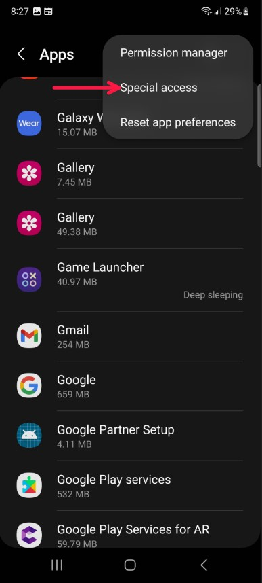
Figure 2: Special Access
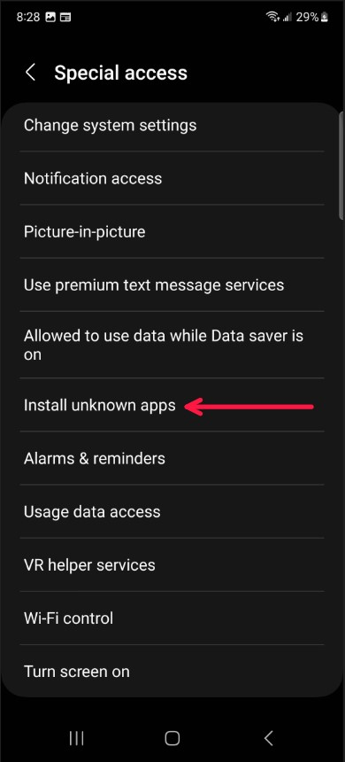
Figure 3: Install Unknown Apps
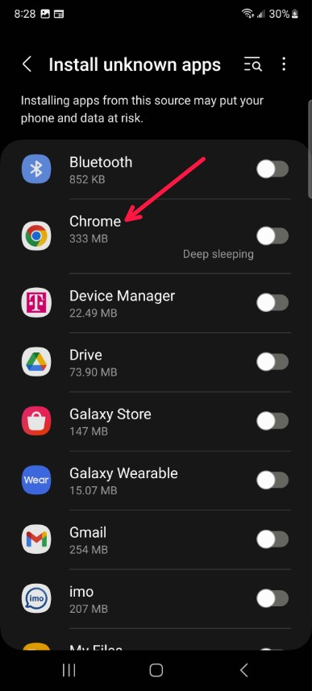
Figure 4: Allow Chrome to Download
Download the application and accept the risk. Use the following screenshots as a guide:
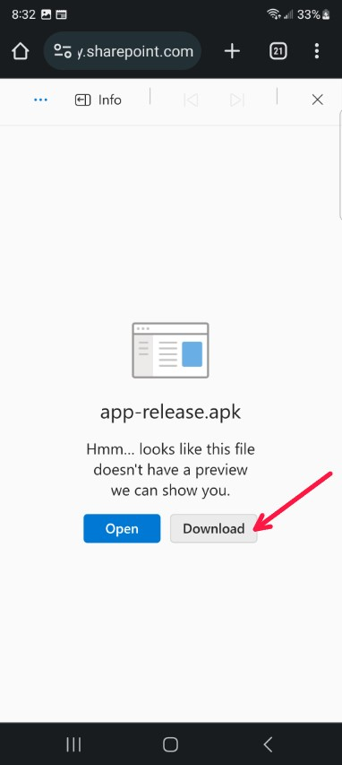
Figure 5: Download the Application
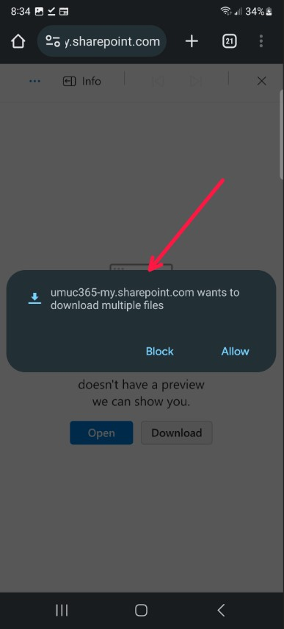
Figure 6: Allow Download Exception
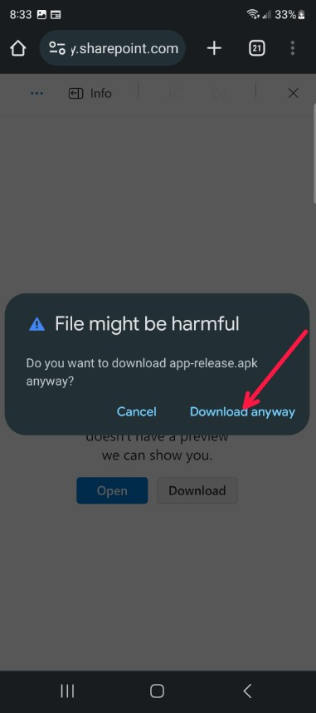
Figure 7: Download Anyway
Install the application and view it on the device.
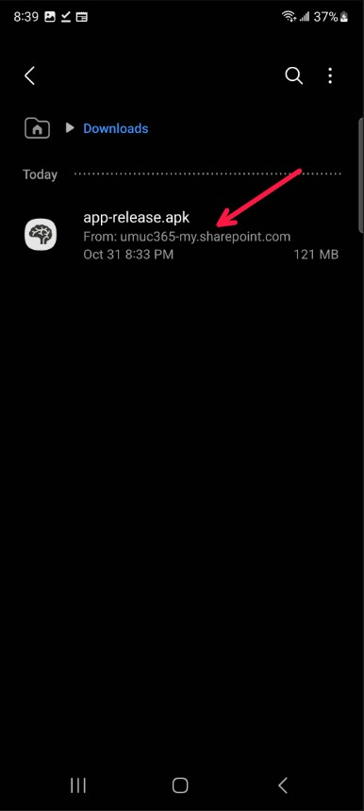
Figure 8: Open Application Download
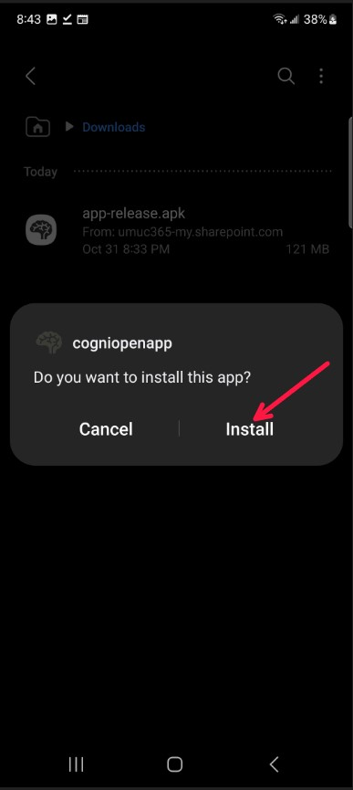
Figure 9: Install Application
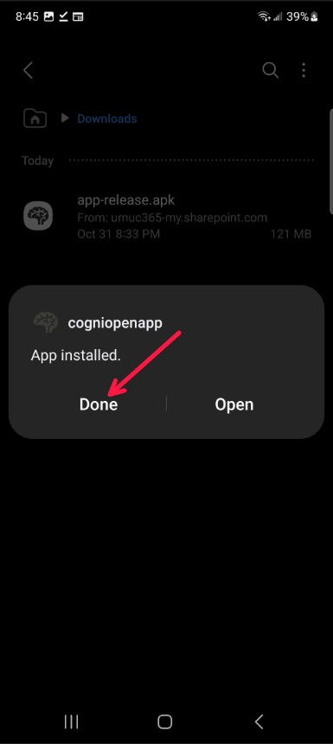
Figure 10: Finish Installation
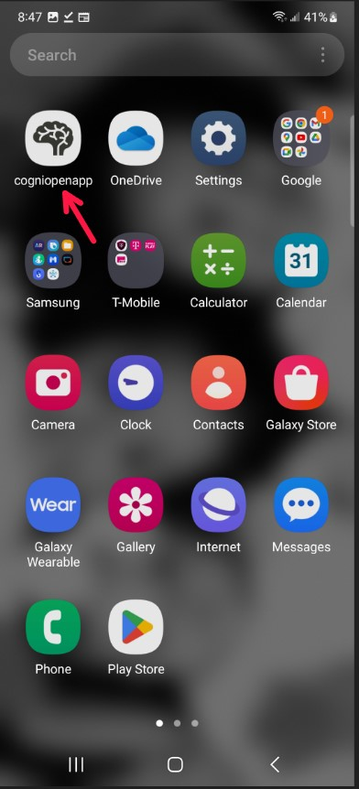
Figure 11: View Installed Application

3. Initial Use

3.1 Application Permissions
The CogniOpen application utilizes both the microphone and the camera to provide services to the end user. While using the application for the first time, users will be prompted to allow or disallow CogniOpen from accessing their phone’s camera and microphone. Additionally, the CogniOpen application will save some data to the local filesystem. Users will be prompted to allow CogniOpen to interact with their local filesystem.
Allow the application to access the location services:
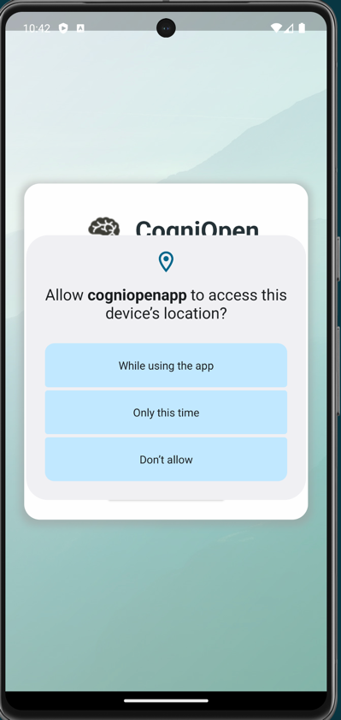
Figure 12: Location Permissions
Allow the application to access the camera:
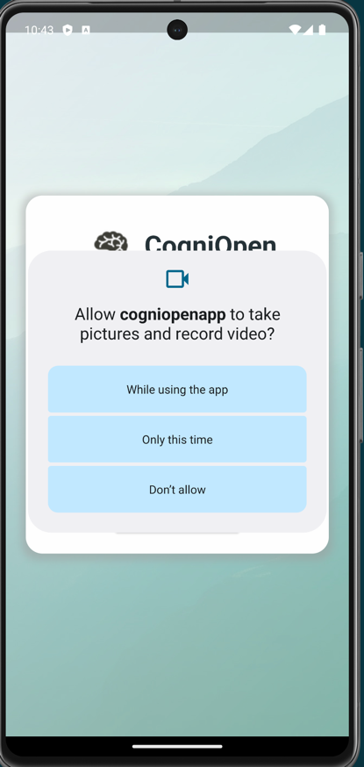
Figure 13: Camera Permissions
Allow the application to access the microphone:
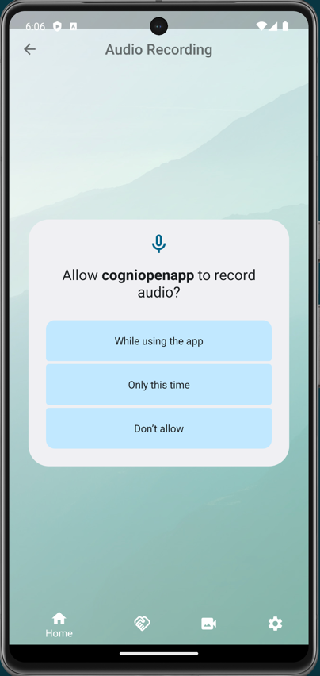
Figure 14: Microphone Permissions
Allow the application to access the local storage:
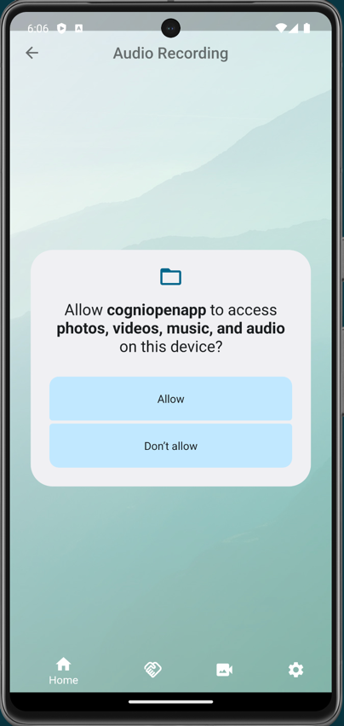
Figure 15: File Permissions

4. Application Usage

4.1 Registration
The registration page is where users will create their own CogniOpen account. This account will contain very little personal information, to minimize potential security risks. This screen will prompt the user for various details in order to associate them, then it will redirect them to the onboarding screen.
- Launch the CogniOpen application.
- Click the “Create Account” button.
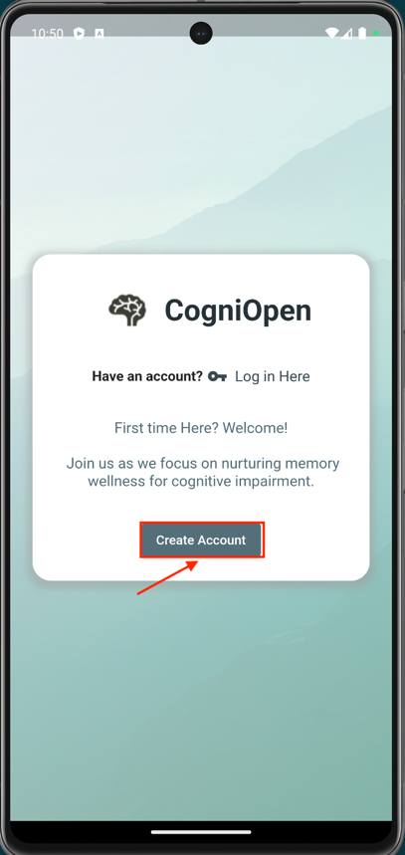
Figure 16: Register for Account
- Fill out the form with the following information:
  - First Name: The user’s preferred first name.
  - Last Name: The user’s preferred last name.
  - Email Address: The email address the user wishes to register the account to.
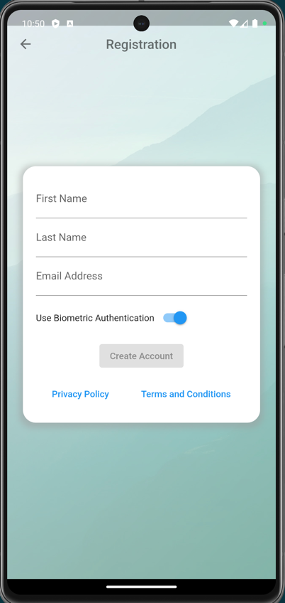
Figure 17: Registration Form
- Click the “Create Account” button.
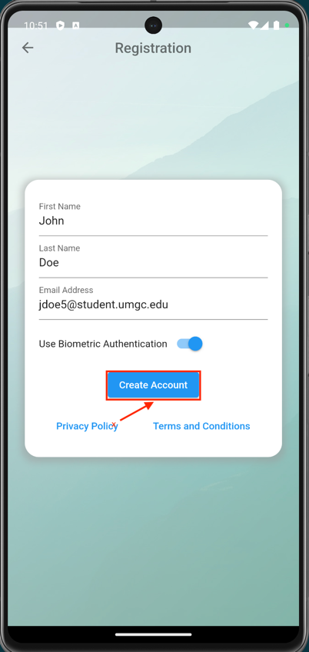
Figure 18: Create Account
After the above actions have been completed. The user will be registered with the CogniOpen application and will be redirected to the onboarding screen.

4.2 Onboarding
New users will be redirected to the onboarding screen after they create their account. The goal of this feature is to familiarize the new users with the application, provide audio snippets for voice attribution, and introduce the users to the CogniOpen Remote Assistant (Cora).
- Launch the CogniOpen application.
- Perform the steps outlined in Section 4.1.
- Perform each action Cora is asking of you, then click the “Next” button.
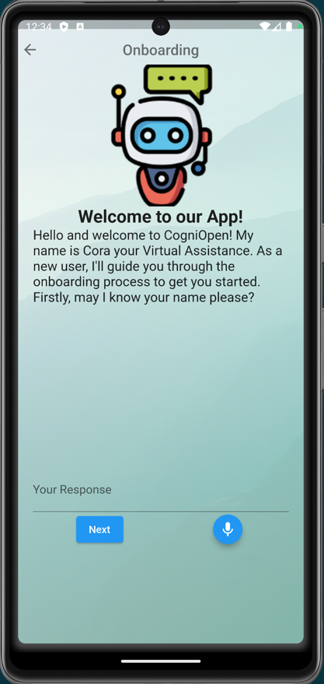
Figure 19: Introduction to the Application
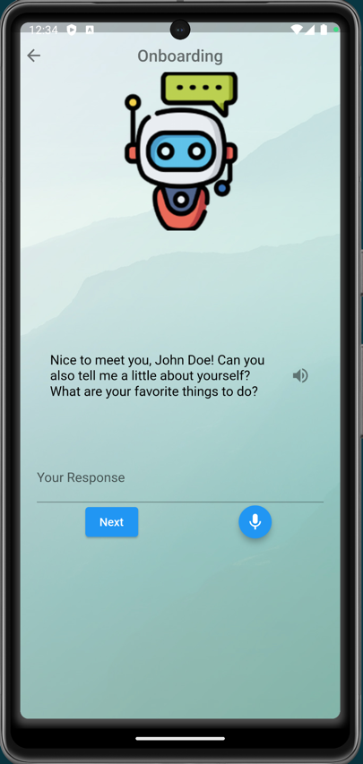
Figure 20: Cora Introduction
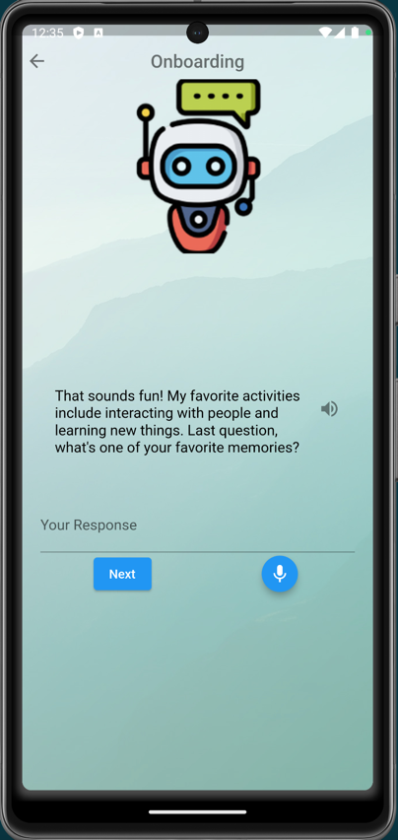
Figure 21: Cora Memories
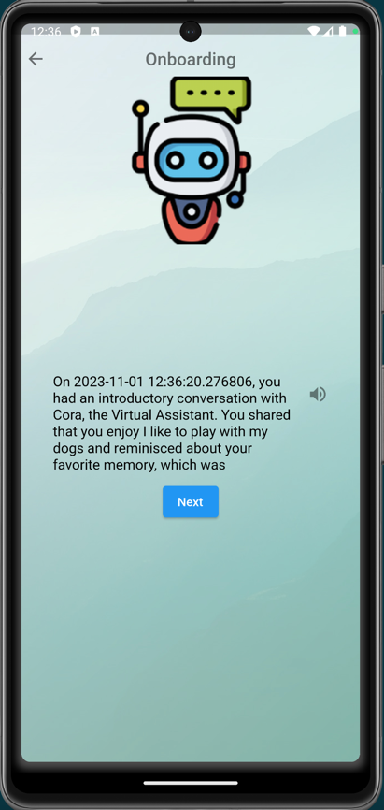
Figure 22: Cora Conversation Summary
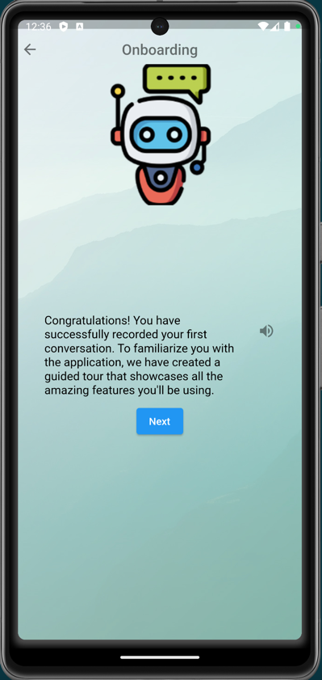
Figure 23: Cora Recording Done
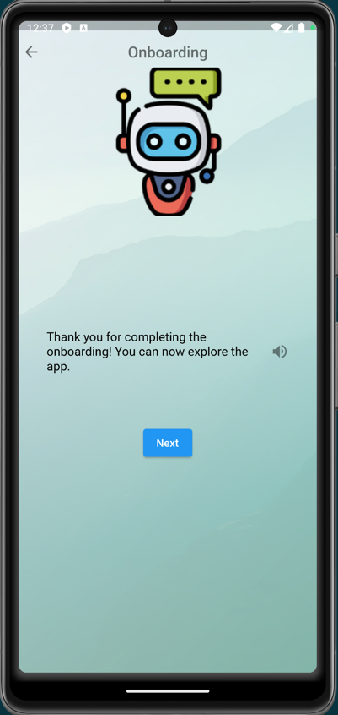
Figure 24: Onboarding Complete

4.3 Login
The login prompt allows users to gain access to their account of the CogniOpen application. Utilizing the native device’s biometric authentication, CogniOpen will prompt the user to validate themselves. After a successful authentication, the user will be redirected to the home screen.
- Launch the CogniOpen application.
- Click the “Log in Here” button.
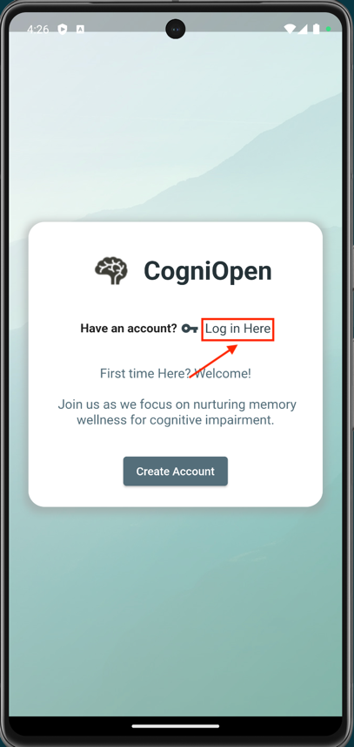
Figure 25: Login Prompt
- Enter your biometric authentication information.
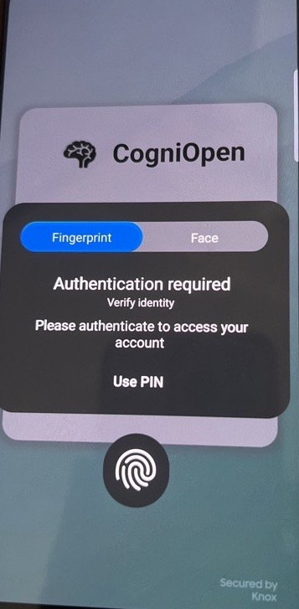
Figure 26: Biometric Authentication
After the user successful enters their biometric authentication information, they will be redirected to the home screen.

4.4 Home
The home page is where the users get to see everything CogniOpen has to offer. After logging into the application, the user will be presented with 6 buttons to select from, each associated to a different core functionality of the application. These individual applications will be discussed below, or in the associated team’s UG.
- Launch the CogniOpen application.
- Click the “Log in Here” button.
- The Home Screen, with 6 buttons will appear – each button related to a Team B feature will be outlined below.
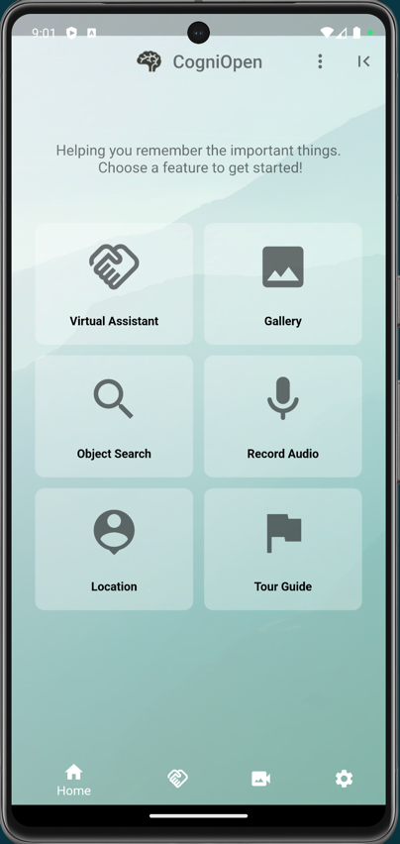
Figure 27: Home Screen

4.5 Guided Tour
The guided tour is designed to reintroduce users to the core functionality of the CogniOpen application with the touch of a button. The guided tour may not always cover 100% of the application’s features, but it will display the core functionality of the application and how to interact with them.
- Launch the CogniOpen application.
- Click the “Log in Here” button.
- Click the “Tour Guide” button.
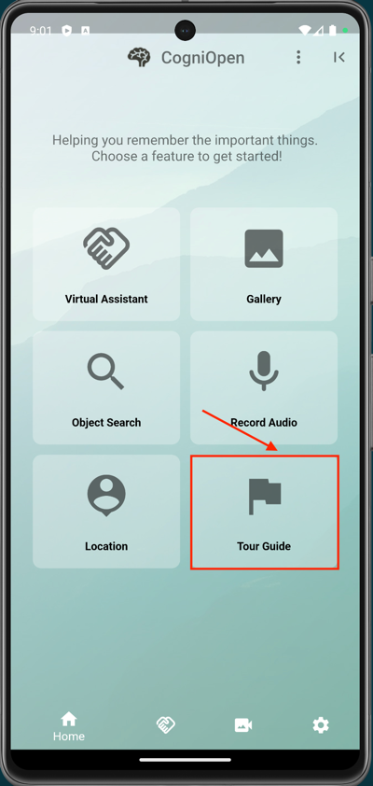
Figure 28: Home Screen Tour Guide Option
- Swipe left, in the direction of the arrow in the following image, to navigate through the guided tour.
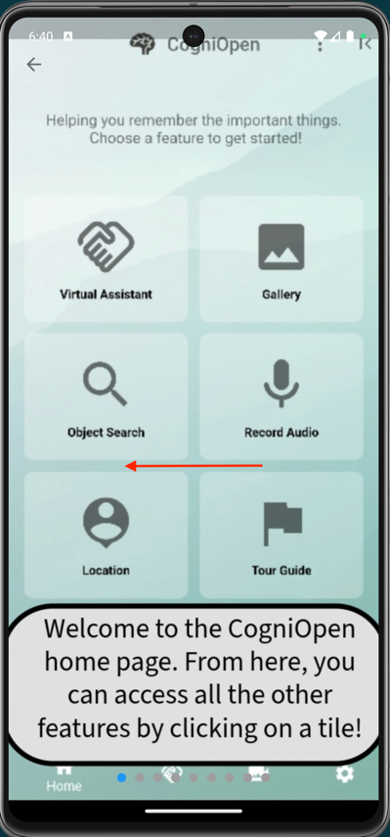
Figure 29: Swipe Through Guided Tour
- After the user has gone through all of the images, or has gotten the information they desire, they can click the top left arrow to return to the Home Screen.
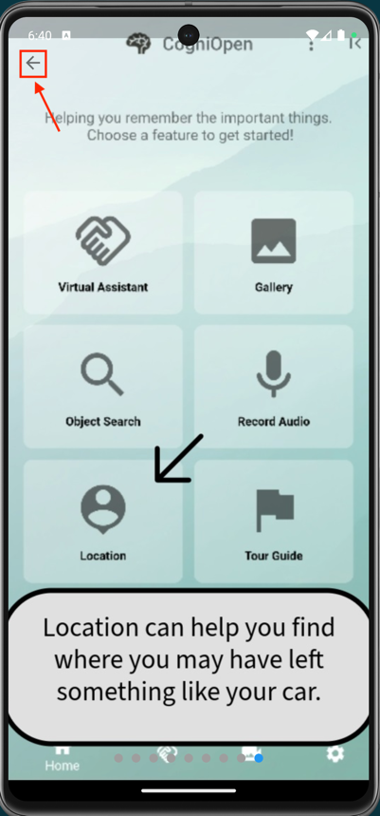
Figure 30: Return to Home Screen

4.6 Profile
The profile screen gives users the ability to update their personal information and to add emergency contact information. Since emergency contact information is not considered critical, it is not included as part of the registration process. However, if the user decides they want to add this information, they can do so through the profile feature. Additionally, if some aspect of their information changes (e.g., their name or phone number), they can make that update with this feature.
- Launch the CogniOpen application.
- Click the “Log in Here” button.
- Click the three-dot kebab menu icon.
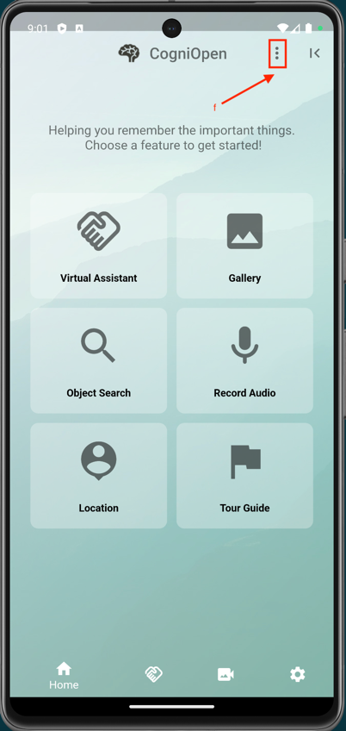
Figure 31: Click Profile Menu Option
- Fill out the form with the following information:
  - First Name: The user’s preferred first name.
  - Last Name: The user’s preferred last name.
  - Email Address: The email address the user wishes to register the account to.
  - Phone Number: The phone number the user wishes to register the account with (in the format 111-222-3333).
  - Emergency First Name: The first name of the user’s emergency contact.
  - Emergency Last Name: The last name name of the user’s emergency contact.
  - Phone Number: The phone number of the user’s emergency contact (in the format 111-222-3333).
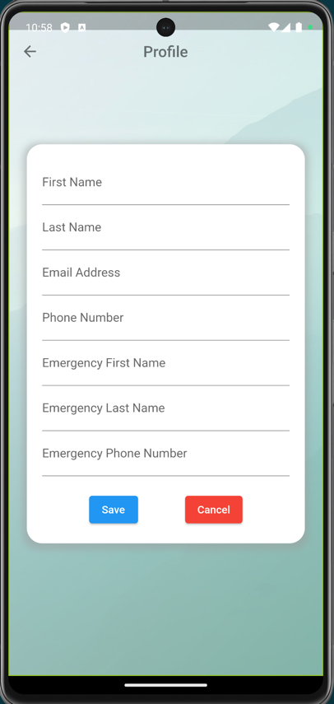
Figure 32: Profile Form
- Click the “Cancel” button to exit the screen without saving or click the “Save” button to save these changes to the user’s profile.
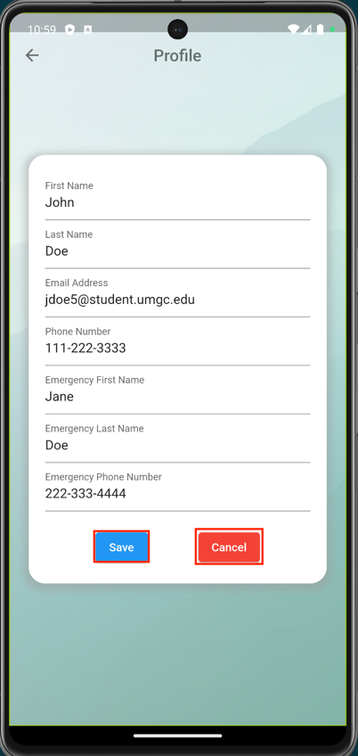
Figure 33: Finish Profile Form

4.7 Record Audio
The record audio feature of CogniOpen allows users to record audio conversations that they may have on demand. By default, video recording will start upon launching the application, but this feature allows users to make a conscious decision to record a conversation. This conversation will be saved, transcribed, and made available in the gallery for querying. Users may want to use this feature when they are going into a doctor’s appointment to remember what happened later.
- Launch the CogniOpen application.
- Click the “Log in Here” button.
- Click the “Record Audio” Home Screen option.
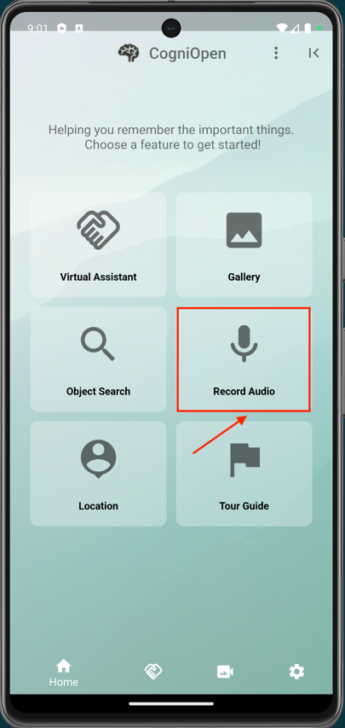
Figure 34: Home Screen Record Audio Option
- Audio recording will be automatically started.
- Hit the stop button to stop recording.
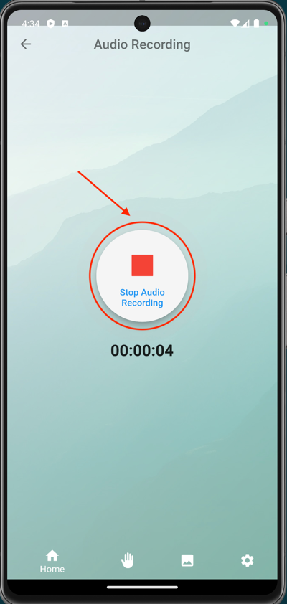
Figure 35: Stop Audio Recording
From here, users can view the transcript of the audio recording, delete the recording, play the recording back, or return to the home screen. The following options are available:
- Click the triangle play button to listen to the audio recording back.
- Click the square button to stop listening to the audio recording.
- Click the trash can button to delete the audio recording.
- Click the “New Recording” button to restart the audio recording.
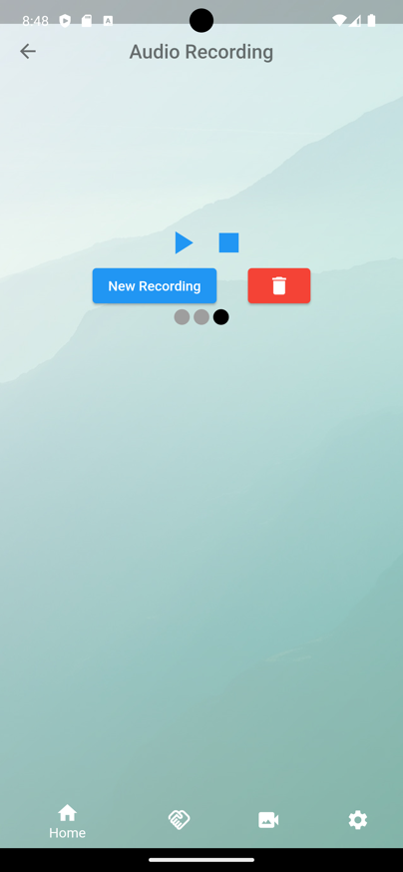
Figure 36: Transcribing Recording
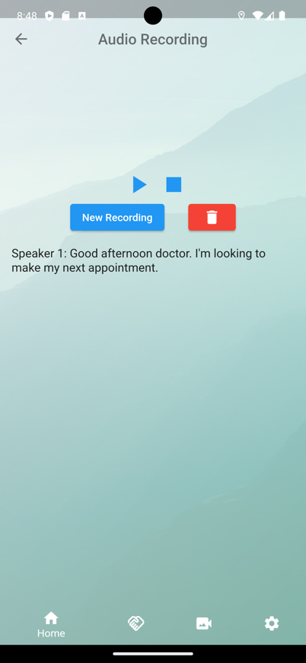
Figure 37: Post Recording Transcription

4.8 Audio Gallery
The audio gallery empowers users to manage their saved audio recordings. In this feature, users can view, replay, delete, and ask the virtual assistant about past recordings. This is the most impactful part of the Team B associated features as it relates to the business case for the CogniOpen application. This gallery gives users the freedom to manage their important audio recordings and ask the virtual assistant for help, significantly improving day-to-day quality of life.
- Launch the CogniOpen application.
- Click the “Log in Here” button.
- Click the “Gallery” Home Screen option.
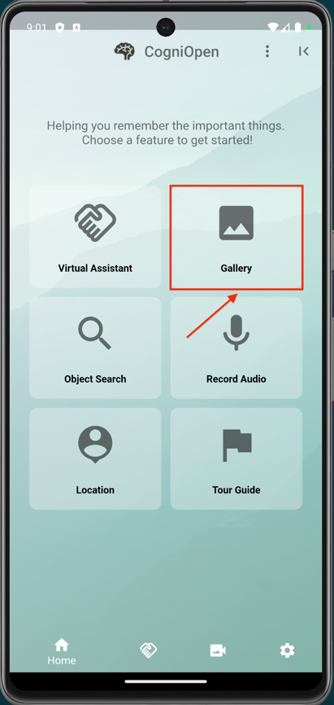
Figure 38: Home Screen Gallery Option
- Select an audio recording.
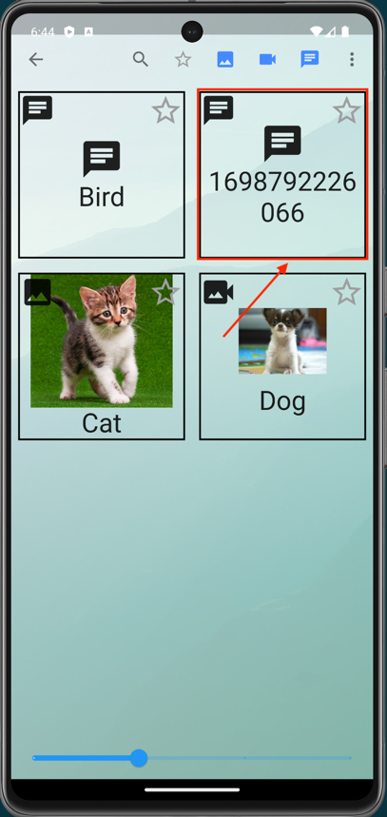
Figure 39: Select an Audio Recording
After selecting an audio recording, users can view the transcript of the audio file, ask Cora about the audio recording or replay the audio recording.
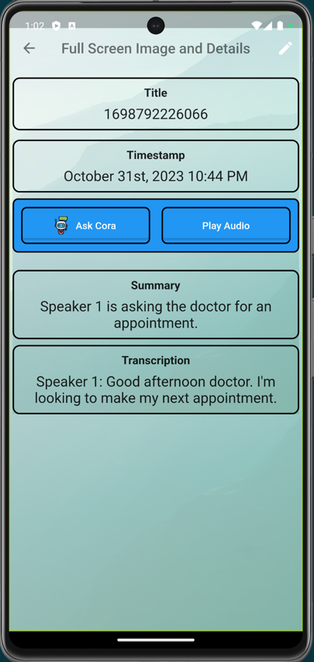
Figure 40: View Audio Recording

4.9 Virtual Assistant
Finally, the virtual assistant gives users a chance to ask an AI chat questions about their conversations or general knowledge questions. Cora is the name we have given to the bot users interact with. Users can enter the virtual assistant screen from the home screen or from the audio gallery. If the user enters from the home screen, they will only be able to ask Cora general knowledge questions. However, if the user enters from the audio gallery, they will also be able to ask Cora targeted questions about their saved recordings. These two options give users flexibility in how they interact with Cora.
- Launch the CogniOpen application.
- Click the “Log in Here” button.
- Click the “Virtual Assistant” Home Screen option.
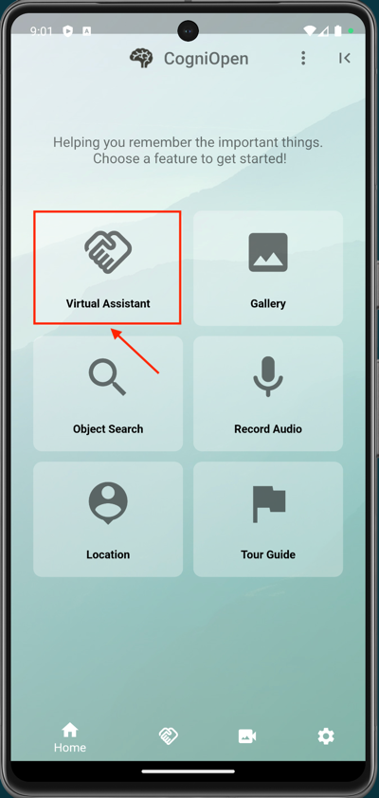
Figure 41: Home Screen Virtual Assistant Option
From here, the virtual assistant Cora will prompt the user to ask them a question. Then, Cora will either provide general knowledge or contextual information about the audio recording delivered from the audio gallery.

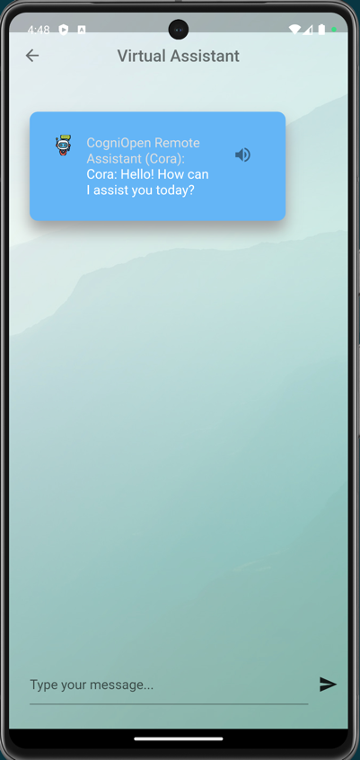
Figure 42: Cora Prompt
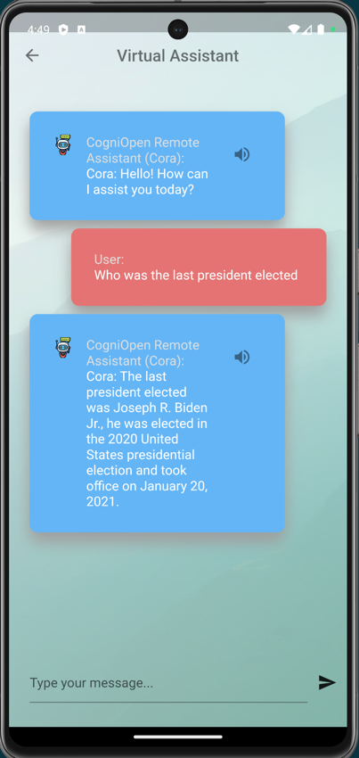
Figure 43: Cora Response

